**Launching EC2 Instance**

* Created Aws Free tier Account
* Selected region 🡪 US east (n. virginia)us-east-1
* Go to the AWS services🡪select EC2 service
* Select launch Instance🡪given as below

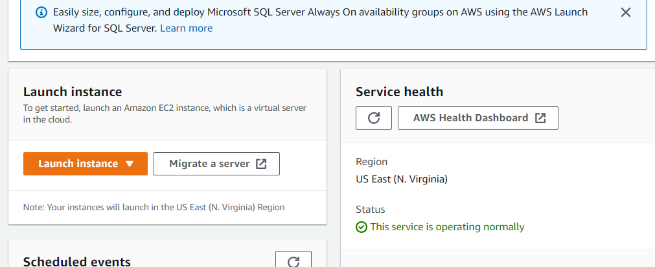

* Give Name to the instaces-🡪Machine Test
* Select Amazon Machine Image🡪Amazon Linux
* Select Instance Type🡪 t2.micro🡪free tier eligible

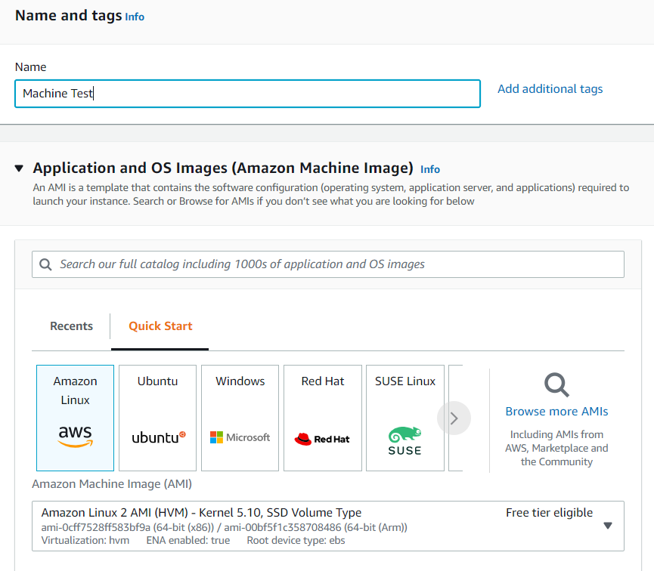

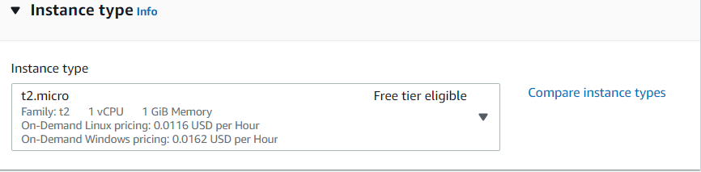

* Create KeyPair
* Select Key pair name, type and format
* Click on keypair Button

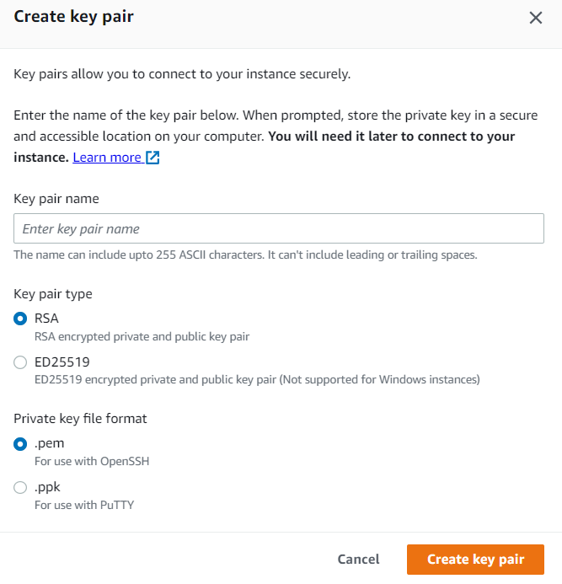

* Select default vpc
* Select Subnet-🡪no preferences
* Auto assign Public IP🡪enable

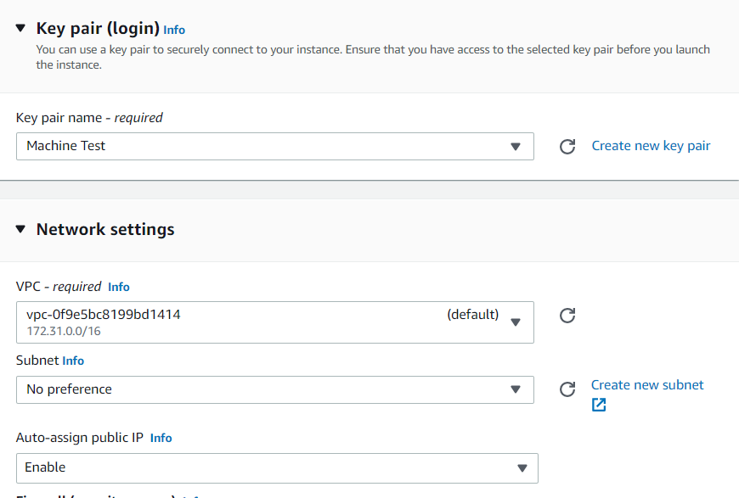

* Create security group-🡪securitygroup
* Select inbound rules🡪select type🡪all traffic🡪source type🡪anywhere

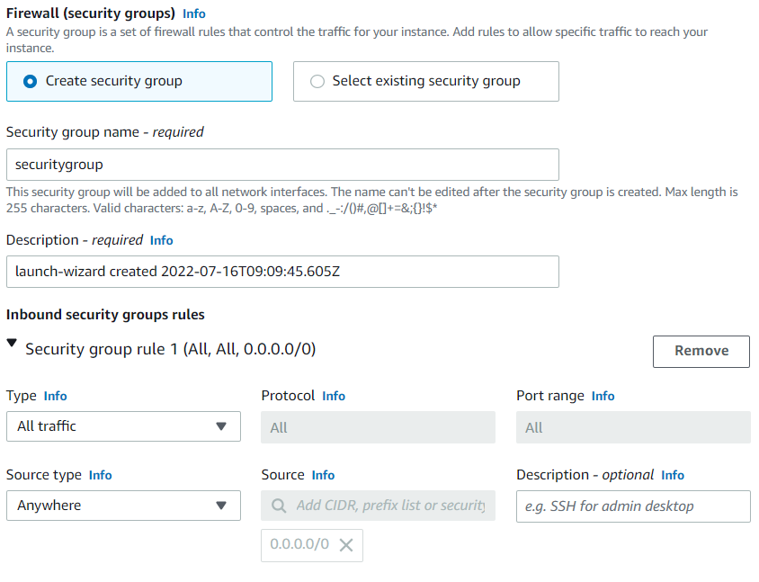

* Click on Launch Instance

